FIELD REPORT

Introduction
- Loyoajonga HC III
- Location: Omoro district, Lakwaya, Loyoajonga
- Date of visit: 2nd September 2026
- General observation
The health facility was operational at the time of the visit, facility in charge present with routine services being provided. The facility had staff and patients present, and the main service areas visited were functional. The general physical condition of the facility was observed to be fair, with some areas requiring attention as noted during the visit.
- The maternity block itself doesn’t have free-flowing water, and patients have to go to the community tap to access water. Luckily it is located via the staff quarters.
- The water tanks attached to the building are empty, citing that there is no pump to take water into the small tank, and also one of the gutters looked bent, thus unable to collect rainwater if any.
- Some of the parts of the block have been turned into a store because the facility itself does not have space to keep the items. They are piled up on top of each other in a disorganized manner. Some machines have been kept on the empty beds piled, which poses a risk of theft as well as damage.
- The facility has no direct current, i.e., UEDCL, so some of the machines that would have been used are not being used. The staff are unable to learn how to use them, thus rendering them redundant.
- Asset verification observations

The majority of the listed assets were physically located at the facility and were generally consistent with the provided records. The condition and functionality of the assets were also assessed during the visit.
Note: Asset register and verification records
No assets were engraved.
At the time of the verification visit, the facility’s asset register was not available for review, although the facility in charge mentioned updating it every financial year and that it was maintained. As a result, the team was unable to use the facility-level asset register to cross-reference or independently confirm the UGIFT-supported assets. In the absence of the facility asset register, the team relied on available delivery notes and payment records obtained from the District Headquarters as reference documents during the physical verification exercise. These records were used to guide the identification and verification of the assets reportedly supplied to the health facility.

The table below illustrates some physical status of the verified assets with photographic evidence.

Table XXX: Physical verification photos
LOYOAJONGA HC III SIGN POST | 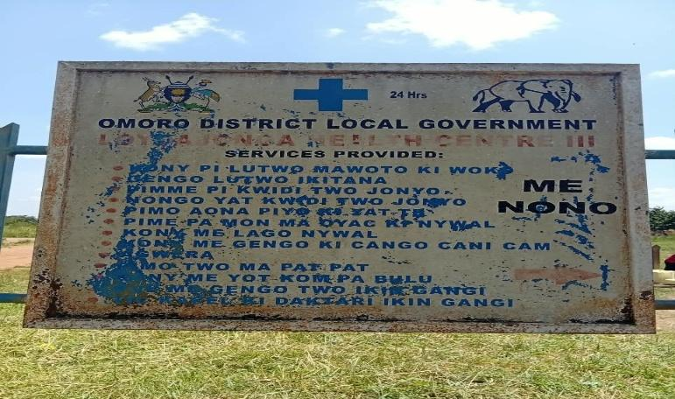
MATERNITY BLOCK (Houses the labor suite, post-natal, inpatient and stores room) | 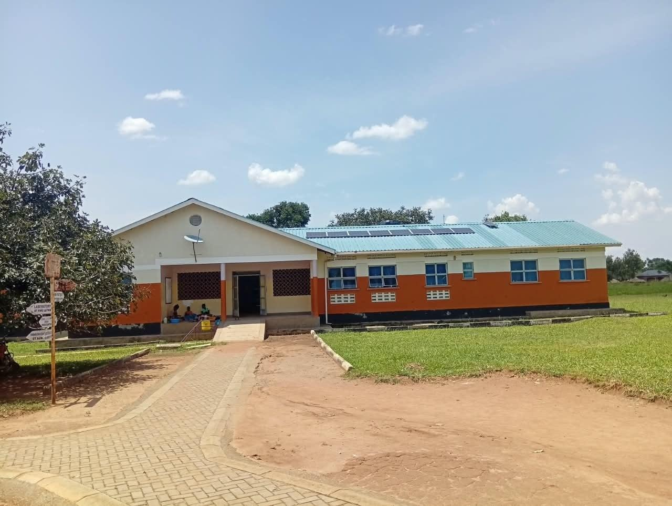
PATIENT LATRINES (Female 4 stanzas Male 4 stanzas | 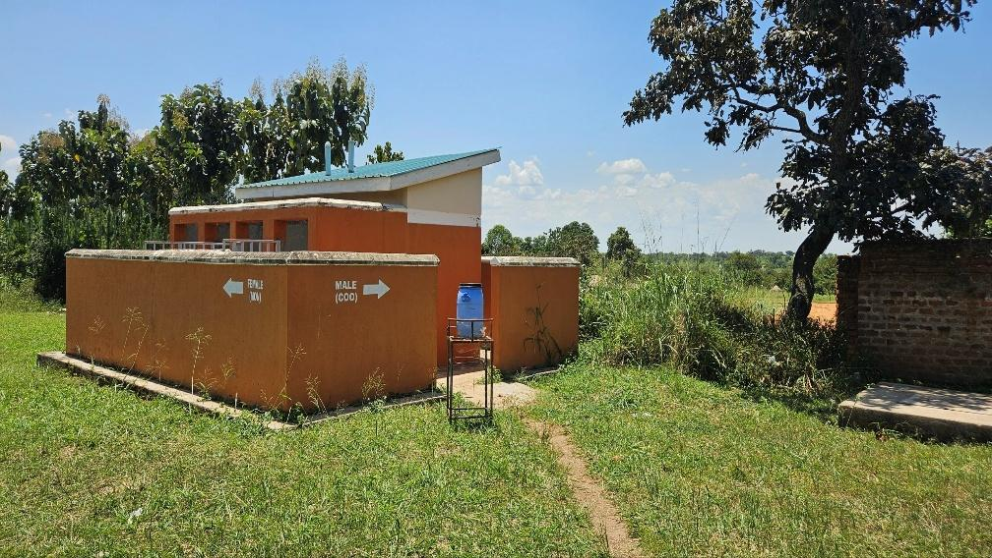
PLACENTA PIT | 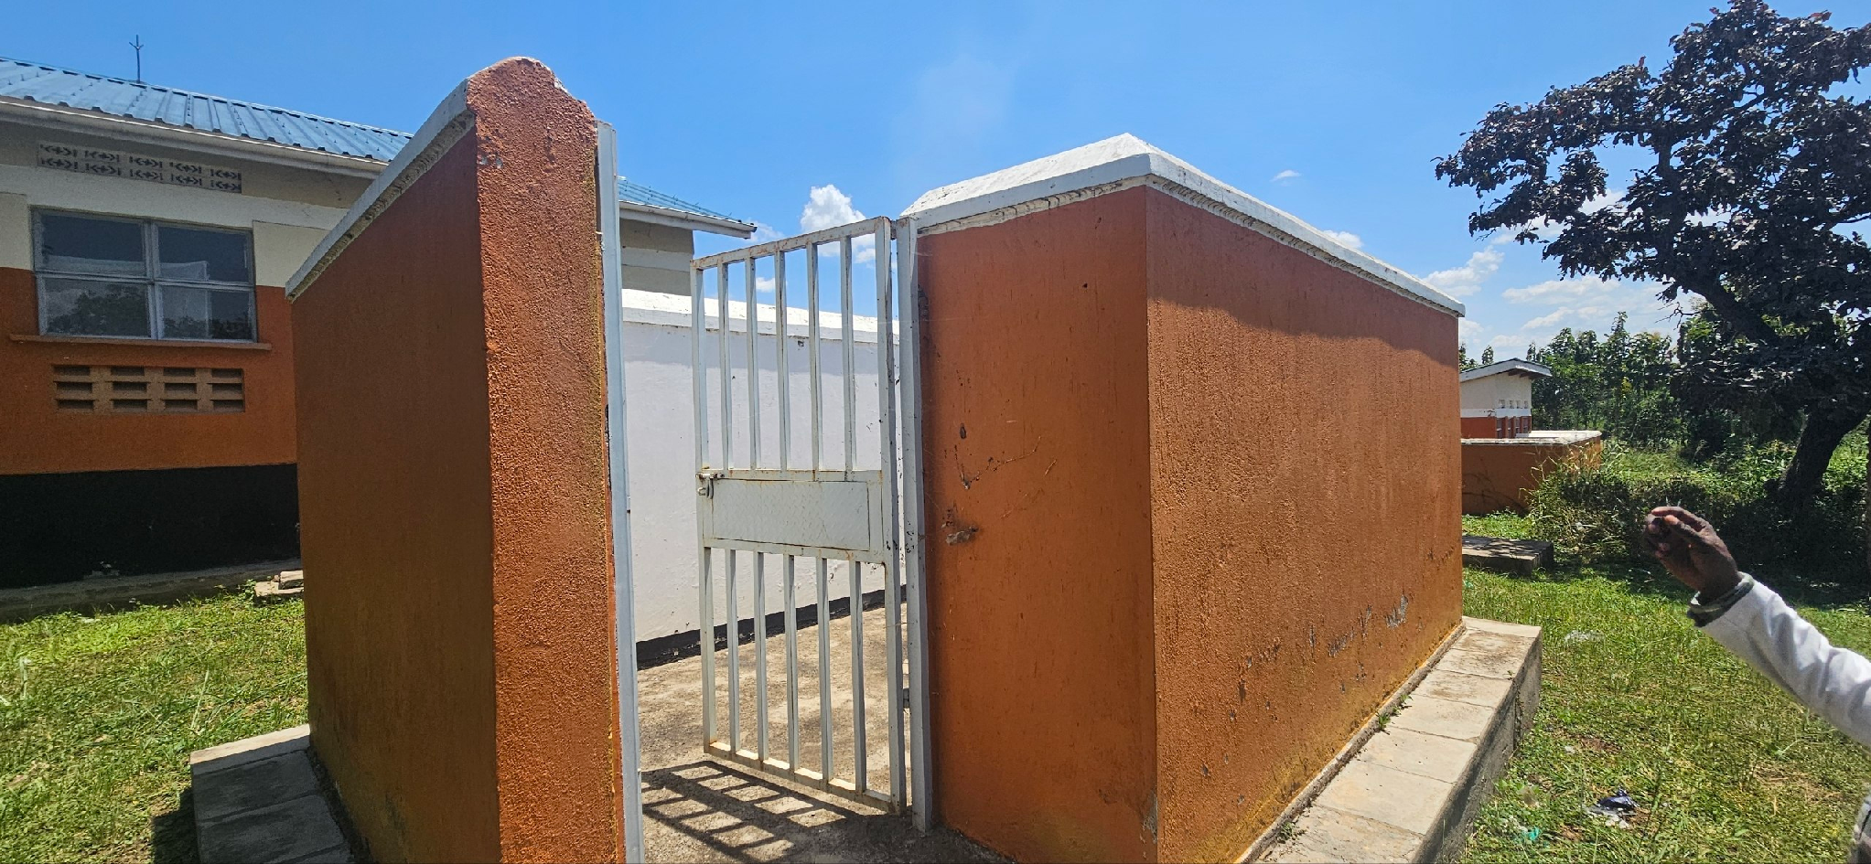
WATER TANKS | 